Unit 1 Exam-Program

Laura Bartlett

Source Code:

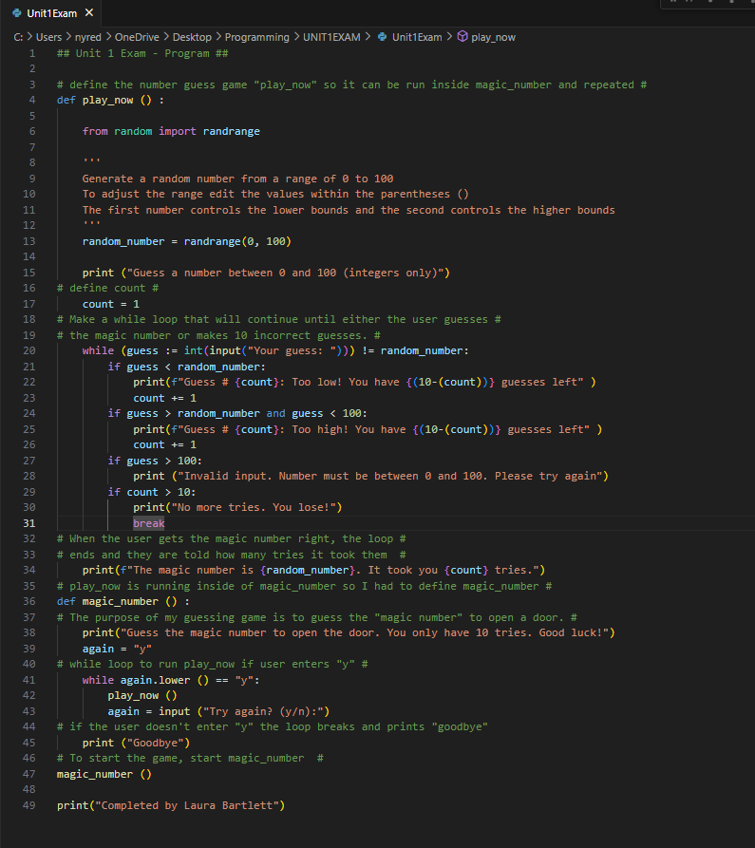

Screenshots from running the program:

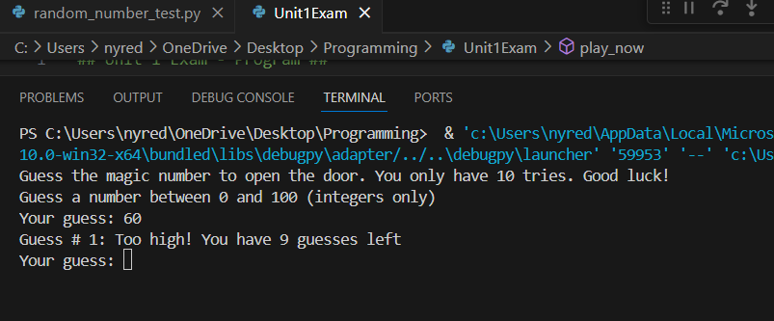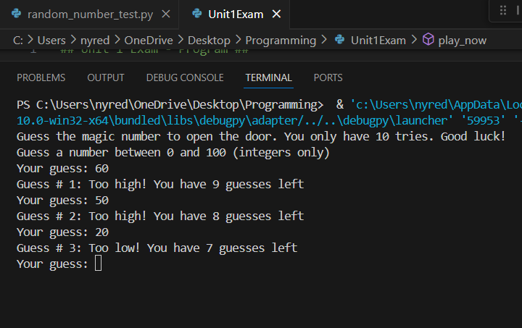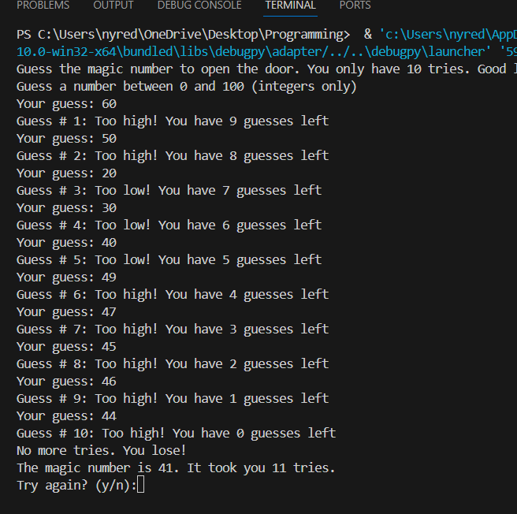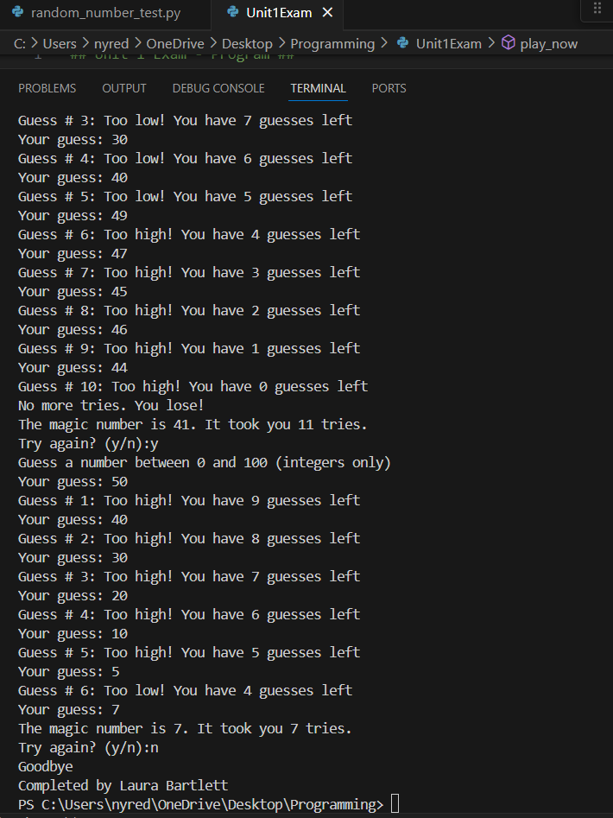

Pseudo-Code:

**Start**

* Define play_game function
  + Get input from user: “Guess a number between 0 and 100”
  + If the input is lower than the magic number:
    - Print: too low, try again, what try the user is on and how many they have left
  + If the input is higher than the magic number
    - Print: too high, what try the user is on and how many they have left
  + If the input is over 100
    - Print “input invalid, try again” and does not count as a try
  + If the user guesses wrong 10 times
    - Print: No more tries
    - Break
  + If the user guesses the magic number
    - Print “the magic number is ____. It took you ___ tries”
* Define game as magic_number
  + Intro to game/rules
  + After game is completed
    - Input from user : “try again? y/n”
    - If user enters “y”
      * Run play_game function
    - If user does not enter “y”
      * Print goodbye

**END**